P1.13

EVALUATING OPTIMAL TECHNIQUES FOR COMPRESSING
NOGAPS DATA SETS FOR QUICK RESPONSE APPLICATIONS

Young Yee*
Mkey Technologies, LLC
3903 Azalea Dr
Las Cruces, NM 88005
TEL: (505)-640-3046
EMAIL: yyee@aol.com

Edward Vidal, Jr
Aldo Lucero
Alberto Aguirre
Sergio D. Cabrera
Department of Electrical and Computer Engineering
University of Texas at El Paso
El Paso, TX 79968

1. Introduction

The potential for national disasters both natural (hurricanes, severe weather, etc) and man-made (release of hazardous materials into the atmosphere) is an increasing problem in today's technological environment. Hazardous releases can occur due to industrial accidents (Chemical spills during transport, Chernobyl incident in 1986, etc). Modern military conflicts and terrorist activities have increased in recent years. In these situations, it is crucial to obtain near real-time meteorological data to initialize quick response forecast and prediction models (Kafatos et.al., 2002).
The NOGAPS (US Navy Operational Global Atmospheric Prediction System) data sets have been used extensively for data quality control, data assimilation, and model initialization (Bayler, G. and H. Lewit, 1992).
______________________________________

* Corresponding author address: Young Yee, Mkey Technologies, 3903 Azalea Dr, Las Cruces, NM, 88005. EMAIL: yyee@aol.com

NOGAPS can provide valuable forcing fields for quick response applications such as severe weather prediction and hazardous aircraft/ship warnings. In these types of applications, timely and expeditious transmission of large sets of NOGAPS data is of utmost importance. Unfortunately, computerized outputs from meteorological models and high-resolution data from weather satellites have been increasing at an alarming rate. Lossless compression algorithms can reduce the volume of data by 2 to 3 times, but to achieve an order of magnitude in better compression performance, lossy compression should be seriously considered. To address the transfer and handling of voluminous data including meteorological parameters and digital imagery, state of the art compression techniques (Cabrera, 2002; Lucero et.al., 2003, 2004, 2005) have made significant progress over the years (JPEG 2000 parts I and II). These compression algorithms can achieve very high compression ratios if certain losses in terms of resolution are acceptable for specific applications. In the atmospheric sciences, where significant events could be lost during the compression and decompression processes, the introduced distortion must be controlled or at least monitored (Seffen & Wang, 2003, Wang and Matsumoto, 2005). The CompressMD™ software tool developed by the Electrical and Computer Engineering Department at the University of Texas at El Paso is used to evaluate various compression techniques appropriate for compressing the NOGAPS data set. A realistic case study is conducted in which a representative NOGAPS data set would have been used to initialize a quick response model. Tolerable RMS errors (RMSE) and maximum absolute errors (MAE) for each meteorological parameter of interest in the data set are pre-selected and incorporated as constraints in the process of maximizing compression ratio. Evaluations of different bit rate allocation techniques are also performed as part of this study.
The first study on lossy compression of GRIB formatted data as a 3D volume from the NOGAPS model (Lucero, et al, 2003) demonstrated that lossy compression ratios on horizontal slices are achievable in the range of 10 to 100.

2. Background

In quick response situations, critical information from a number of sources must be accessible at a moments notice. The NOGAPS data sets are widely available through the Internet and can provide essential initial and boundary conditions for local weather and dispersion models.

2.1 The NOGAPS Forecast Model

The NOGAPS forecast model is a global model that is spectral in the horizontal direction and energy-conserving finite difference (sigma coordinate) in the vertical direction. The model top pressure is set at 1 hPa; however, the first velocity and temperature level is approximately 4 hPa. The variables used in dynamic formulations are vorticity and divergence, virtual potential temperature, specific humidity, surface pressure, skin temperature, and ground wetness. In September 2002, NOGAPS 4.0 was increased in resolution from T159L24 to T259L30, an increase in equivalent grid point resolution from about 0.75 to 0.5 degrees.
The operational T239L30 NOGAPS (4.0) runs in a massively parallel system and executes several times each 00-UTC and 12-UTC watch, including a six-day forecast completing approximately five and one-half hours past the synoptic time. NOGAPS currently outputs close to 25,000 gridded fields per day. Products from NOGAPS are distributed to a worldwide customer base. NOGAPS also provides essential and tailored input to many other models, including the Navy's advanced Coupled Ocean-Atmosphere Mesoscale Prediction System (COAMPS), ocean wave model, sea ice model, ocean circulation model, ocean thermodynamics model, tropical cyclone model, aircraft and ship-routing programs, and application programs at both FNMOC (U.S. Navy's Fleet Numerical Meteorology and Oceanography Center) and the Air Force Weather Agency (AFWA). Along with the GFDL tropical cyclone forecast model and the UK Met Office and Japanese global models, NOGAPS is a primary tropical cyclone forecast tool for forecasters at the Joint Typhoon Warning Center (JTWC) and the National Hurricane Center (NHC). NOGAPS can be used to provide input data to meso-scale weather models such as MM5 (The Fifth-Generation National Center for Atmospheric Research/Penn State Mesoscale Model) (NCAR, 1998). NCAR supports a unified (global/regional, multi-model, 3/4D-Var) model-space variational data assimilation system (WRF-Var) (Barker, 2004) and RAMS (Regional Atmospheric Modeling System) (Piekle et al., 1992), which are already under extensive study and are widely used. Linked systems such as OMEGA (Operational Multiscale Environment model with Grid Adaptivity) (SAIC, 2002) and HPAC (Hazard Prediction and Assessment Capability) (DTRA, 2002) could be run to predict the dispersion of hazardous materials in the atmosphere.

2.2 Quick Response Models

Quick response dispersion models including the OMEGA, the Operational Multiscale Environment model with Grid Adaptivity, the SAIC (2002) system and DTRA's Hazard Prediction & Assessment Capability (HPAC) model could benefit from readily available NOGAPS data for initialization. Utilizing an adaptive unstructured grid technique, the output from OMEGA can be a large, multi-dimensional dataset. One of the challenges includes the handling of the massive size of the OMEGA mesh output covering large geographic areas. The OMEGA has been applied to data from hurricane Floyd (1999), and to the smoke dispersion from the Indonesian fires of 2002.
Figure 1. Overview of the NOGAPS compression process for initializing mesoscale and dispersion models
HPAC is a Gaussian puff model which uses a second order closure model for the treatment of the turbulence component. HPAC predicts hazards from nuclear, biological, chemical, and radiological (NBCR) weapons and facilities. HPAC models atmospheric dispersion of vapors, particles, or liquid droplets from multiple sources, using arbitrary meteorological inputs including 4-dimensional gridded wind and temperature fields.

2.3 Compression Process

Figure 1 shows the compression process for a proposed operational system where NOGAPS uncompressed data and user's allowable errors for the meteorological parameters are fed into the CompressMD central site to be processed. Once the NOGAPS data sets have been optimally compressed, it is packaged and sent to the quick response models of interest.

In quick response applications, the following points need to be considered:
● Transfer data rates
● Controlling the data integrity
(RMSE and/or MAE)
● Reliable algorithms
● Automated operations
● Simple processes

3. CompressMD™ Software Tool

The multi-dimensional compression software used in these studies was designed as an analysis and evaluation tool for testing the performance of various compression engines and providing the necessary modules to evaluate the compression/ decompression results. The software uses several open sources packages such as Jfree Chart, the Java-based plotting programs to provide XY sliced plots of the data; the Colt library to provide the matrix operations; JJ200, JPEG 2000 implementation in Java; and the NETCDF & GRIB readers and writers to provide file input and output functions. The primary goals of CompressMD are (a) to be able to use the software tools in a research environment mode in order to investigate specific performance aspects of the compression process and (b) to be able to use the modules in an operational mode for specific applications by non-experts.

3.1 CompressMD Software Packages

CompressMD contains software packages that provide: Data Matrix manipulations, Bit Rate Allocations, Quantizers, KLT & DWT Transforms, Plug-ins, Input/Output operations, Metrics computations, Data Handling, and Remote Operation capabilities. In the Bit Rate Allocation procedure, much work has been completed in developing, implementing, and evaluating several bit rate allocation methods: Scaled Log-Variance allocation, Traditional Log-Variance allocation, JJ2K RDO, RDO and Mixed Model. Planned in the design but not implemented yet is the use of Plug-Ins, which should allow the user to extend the software features. A user could design a new bit rate allocator and by placing the classes in the proper location would be able to use all of the features of CompressMD which include user interfaces for Windows, Tables, and Plotting managers.

3.2 KLT & DWT Characteristics

The two major inter-slice decorrelation methodologies in the compression world are the Karhunen-Loeve transform and the discrete wavelet transform. The key characteristics of these two transforms are outlined next.

1. Karhunen-Loeve (KLT) Transform Characteristics
a. The KLT is designed to provide the most energy compaction
b. The KLT can be computationally intensive
c. The KLT can be impractical for time-sensitive applications if the third dimension is very large. For example hyperspectral images comprised 1500 slices in one application. The NOGAPS compression studies involved only 20 slices for each parameter.
d. The KLT requires additional overhead of 0.0098 bpp on a 20 X 181 X 360 data set used in this study.

2. Discrete Wavelet Transform Characteristics
a. The DWT does not have any data dependency
b. The DWT is simpler to calculate
c. The DWT is faster, but in general, suboptimal in energy compaction

3.3 Features

The features of the CompressMD software used in this study are briefly discussed.
- Inputs Multi-Data Types in Multi-Data Formats
- Multi-dimensional Data (3-D and higher)
- Graphical and tabular representation of metrics
(SNR, MSE, RMSE, MAE, range of data, target bit rates
entropy, power, variance, others)
- Two modes: Research mode and operational “black box” mode
- Residual encoding capability

3.4 Meteorological Data Types

Meteorological data types that the software tool can handle are
- Meteorological model 4D Data
  - GFS
  - NOGAPS
  - WRF
  - MM5
  - BFM
- Medical 3D data (Aguirre, et.al., 2004)
- Satellite 3D data (Motta, et.al., 2003; Magli, et.al., 2004; Melchor, 2004)
- Image 2D data
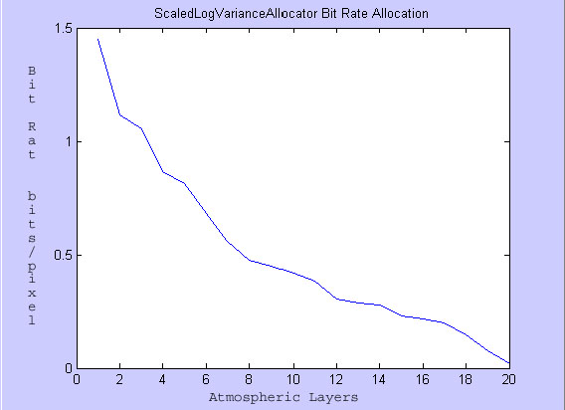
Figure 3. Scaled Log-Variance Bit Rate Allocation for a sample NOGAPS data slice.
3.5 Bit Rate Allocators

Optimizing the bit rate allocators for individual slices of data has shown to minimize the distortion in the 3D meteorological data compression. The bit rate allocator methods are
- Scaled log variance Uses all Z dimension Slices and offsets when bpp < 0
- Iterative log variance
- Mixed Model
- RDO (Rate Distortion Optimal for validation purposes, computationally intensive)
- JJ2K RDO (exploited part of JJ2000)

4. JPEG 2000 Part II with Residual Coding

A block diagram of the overall compression procedure is shown in Figure 2. Transform in z-direction can
Figure 2. Schematic of the CompressMD software compression process.
be either KLT or DWT. The desired Maximum Absolute Error can be selected, and we search for the lowest compression ratio possible. An example of output from one of the bit rate allocation algorithms is shown in Figure 3. The lowest atmospheric layer is 0, which represents the surface, and the highest layer is 20, which is the 10mb level.

Parameter codes are chosen for each meteorological variable i.e. temperature, dew point temperature, u-component and v-component of the wind, and Geo-potential height. Other input parameters include the highest and lowest atmospheric levels, the forecast period, the user's target compression bit rate, the maximum allowable error for a particular meteorological parameter, and the transform method (KLT or DWT). From these inputs, a 3-Dimensional meteorological data set is extracted from the data archives and inserted into the CompressMD model. The results from a typical run are the compressed bit stream data file, an overhead file that contains information on the data, and the encoded residuals as shown in the data to be transmitted box (figure 2).

The Proposed GRIB 3D compression process would be as follows:
•GRIb decoder reads and loads desired 3-D data set (multiple 2-D slices) to memory
•Preprocessing in Z direction using KLT or DWT.
• 2D compression of each slice using JJ2000.
•Post processing in Z direction inverse KLT or DWT.
•Computation of residuals and their lossless compression using JJ2000 with 0 levels of DWT
•Transmission of data to the client (e.g. from AFWA to IMETS).

5. Controlling the allowable or maximum errors

In order to accurately initialize quick response models, tolerable or allowable errors must be defined in advance. Depending on the model characteristics, the allowable errors can be stringently low or reasonably large without affecting a quick response model's forecast. As noted above, an added sub-process, "residual encoding", was added to control the maximum absolute errors in the decompressed data set. In the residual encoding process, the user specifies a desired maximum absolute error to maximize the compression ratio. In the first case, the algorithm will compute the best compression ratio for the specified maximum absolute error. For demonstration, the original (uncompressed) global surface temperature field from a NOGAPS data set was mapped in Figure 4.

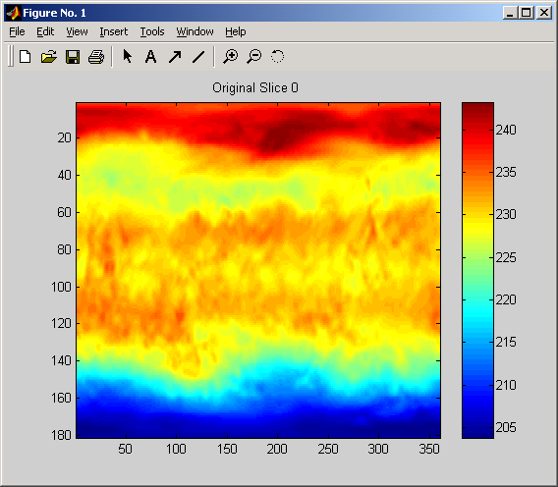
Figure 4. Original NOGAPS surface temperature field with longitude (degrees) on the x-axis and latidutde (degrees) on the y-axis. Temperature scale is in Kelvin degrees.
After employing the residual encoding model to achieve a MAE of .5 degrees K, the Compressed/Decompressed (C/D) version of the surface temperature field is mapped in Figure 5. Figure 6 is the difference between the original and the C/D slice.

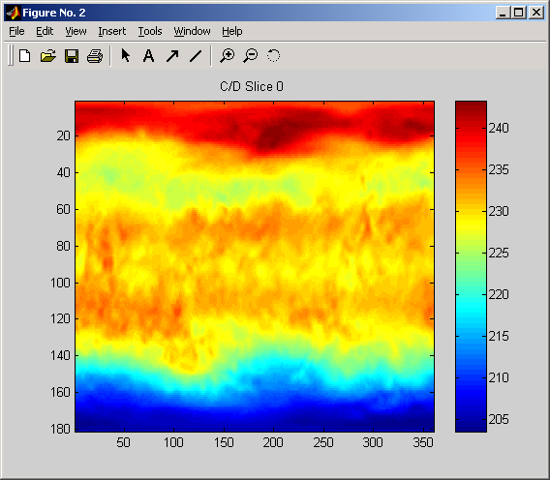
Figure 5. The Compressed/Decompressed (C/D) NOGAPS surface temperature field with longitude (degrees) on x-axis and latidutde (degrees) on the y-axis. Temperature scale is in Kelvin degrees.

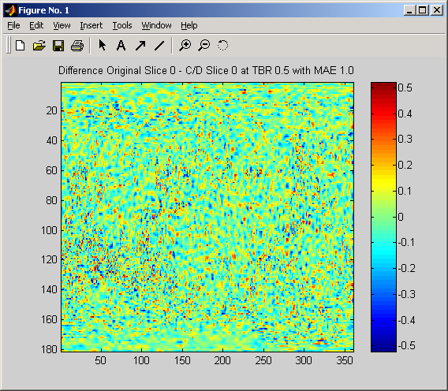
Figure 6. Difference between the original NOGAPS surface temperature field and the C/D version with longitude (degrees) on the x-axis and latidutde (degrees) on the y-axis. Temperature scale is in Kelvin degrees.

6. Sample NOGAPS Case

To illustrate the procedure of the proposed compression process, a typical NOGAPS data set (Oct 15, 2002) was retrieved, compressed, and analyzed. The user inputs are the following desired maximum allowable errors.

6.1 User Defined MAE for sample case

User's Reasonable Desired MAEs for the sample test case are listed:

Geo-Potential Height 10 meters
Temperature 1 deg K
Dew Point Temp 5 deg K
U component of wind 1 m/sec
V component of wind 1 m/sec

Figure 7 depicts a GRib temperature data set where the vertical z direction is chosen to define a collection of 2D horizontal slices, i.e. atmospheric layers. 3 layers out of 20 are displayed in the diagram (1000mb, 50mb, and10mb).
The specifications of the computer used to benchmark the operational performances are listed:

Processor: Pentium 4, 3.0 GHz
Operating System: Windows XP
Professional
Memory: 2.5GBytes RAM

6.2 Analysis of Meteorological Parameters Compression

For this analysis, 20 atmospheric layers and five NOGAPS meteorological parameters were requested from the Master Environmental Library. The NOGAPS data set is in Gridded Binary (GRIB) format containing 20 horizontal slices or levels, i.e. z-direction, and each slice consists of 181 by 360 x-y grid points corresponding to 1 degree spacing in latitude and longitude, covering the world. Applying the CompressMD tool to the downloaded GRIB data set, the four bit allocation techniques studied were the iterative log variance, the scaled log variance, the JJ2K RDO, and the RDO. Results of the five meteorological variables selected (Geo-Potential heights, Temperature, Dew Point Temperature, U component of the wind, and the V component of the wind) using the KLT transform are shown in Tables 1-4. Table 1 summarizes the bit rates for the different bit rate allocation techniques using the KLT transform. For each of the meteorological parameters, the JJ2K RDO technique produced the lowest bit rates. This is equivalent to producing the highest compression ratios for this case (Table 2). The corresponding tables (Tables 3-4) are the achieved final maximum absolute errors (MAE) and the time to process each technique in seconds, respectively.
Figure 7. For the NOGAPS data set, a series of 20 horizontal data slices for each meteorological parameter is chosen for pre-processing.
Tables 5-8 show results from performing analysis on the GRIB NOGAPS using the DWT transform. The DWT performance in terms of compression ratios, time to process, and MAEs is comparable to the KLT performance. The matrix operations in the KLT, using only 20 slices in the z-direction, do not appear to affect the computational performance. On the other hand, in previous studies, the compression of satellite hyperspectral images, where the matrices are very large i.e. 1500 slices in the z-direction, the KLT transform performance was considerably slower.

7. Summary

The CompressMD tool is a Java implemented application that was developed to provide a comprehensive environment for the evaluation of compression algorithms. The tool was structured to ingest a variety of data formats and multi-dimensional data sets and types. The user can choose between two kinds of transforms (KLT and DWT). The residual encoding step is an additional procedure to optimize the bit rate allocation and to lower the RMS errors by using filtering out outlaying data points and compressing the residuals.
For one now cast and four forecast periods, there were 437 files. The data file size for one forecast period is approximately 37.8MB. For all the forecast periods, the data file size is 193.7MB. There are five meteorological parameters and 20 atmospheric layers. The time to compress all the layers was less than 6 minutes. To decompress the same layers took less than 4 minutes. Compression ratios varied widely depending on the meteorological parameter. The JJ2K RDO performed best overall with achievable compression ratios between 19 and 100.
In all cases, the different compression algorithms achieved the MAE original goals. In general, there is no generic compression methodology for all the applications. Each application will have special needs that will need to be experimented and fine tuned as much as possible. Data interoperability can be a major issue when integrating compressed/uncompressed data files into other systems. One solution to this problem is to use standard data transport protocols for passing data.

8. Conclusion

The most important requirement of a quick response system is the speed of achieving current information. To achieve this goal, massive real-time data sets must be readily available to run weather and dispersion models as well as evacuation models. For example to transmit a typical 38MB NOGAPS data set for a single forecast period on a 56Kbaud line might take 90 minutes whereas a compressed 1MB NOGAPS data set with allowable errors may take as few as 2 minutes to receive. In quick response situations, latencies of minutes can be life threatening. Therefore, by allowing the user to control the maximum absolute error, lossy compression can be used in these cases. A technique that can achieve this has been presented.
Building an operational rapid response system can be a complicated process. There are many issues that must be resolved before the system can be integrated. System integration will require extensive collaboration among various fields. One important discipline is the optimal use of compressed large data sets in order to obtain expeditious meteorological information for quick response applications. As technology advances, high resolution data sets are becoming unmanageably large. Optimal compression techniques may prove to be invaluable for rapid data transmission and compact data storage.

9. References

Aguirre, A., S.D. Cabrera, E. Vidal Jr., A. Lucero, O. Kosheleva, and K. Gerdau, “Compression of Three-Dimensional Medical Image Data Based on JPEG2000,” in Proc. Of 17th IEEE Symposium on Computers in Biology and Medicine (CBMS), pp. 116-121, Bethesda MD, June 2004.

Barker, D. M., W. Huang, Y. R. Guo, and Q. N. Xiao., 2004: A Three-Dimensional (3DVAR) Data Assimilation System For Use With MM5: Implementation and Initial Results. Mon. Wea. Rev., 132, 897-914.

Bayler, G. and H. Lewit, "The Navy Operational Global and Regional Atmospheric Prediction System at the Fleet Numerical Oceanography Center", Weather and Forecasting, Vol. 7, No. 2, June, 1992.

Cabrera, S.D., "Three-dimensional compression of mesoscale meteorological data based on JPEG 2000," Proc. SPIE, Vol.4741, Battlespace Digitization and Network-Centric Warfare II; Raja Suresh, William E. Roper; Eds., Aug 2002.

DTRA (Defense Threat Reduction Agency), 2002, Hazard Prediction Assessment Capability (HPAC), http://www.dtra.mil/rd/programs/acec/hpac.cfm.

Kafatos, M., R. Yang, C. Yang, R. Gomez, and Z. Boybeyi, "Utilizing Remote Sensed Data in a Quick Response System", Pecora/Land Satellite Information IV/ISPRS Commission I/FIEOS 2002 Conference Proceedings.

Lucero, A., S.D. Cabrera, A. Aguirre, and E. Vidal Jr., “Impact of Residual Encoding on Minimizing and Controlling Maximum Absolute Error in Scientific Data Compression,” 39th Annual Conference on Information Sciences and Systems 2005.

Lucero, A., S.D. Cabrera, A. Aguirre, E. Vidal Jr., and Miguel Argaez, “Comparison of Bit Allocation Methods for Compressing Three-Dimensional Meteorological Data after Applying KLT,” IGARSS Conference 2004, Anchorage, Alaska, September 2004.

Lucero, A., S. D. Cabrera, A. Aguirre, and E. Vidal Jr., “Compressing three-dimensional GRIB meteorological data using KLT and JPEG2000,” IEEE Intl. Geoscience and Remote Sensing Symposium 2003, CD-ROM, 3 pages, Toulouse, France, July 2003.

Magli, E., G. Olmo, and E. Quacchio, “Optimized Onboard Lossless and Near-Lossless Compression of Hyperspectral Data Using CALIC,” IEEE Geoscience and Remote Sensing Letters, vol. 1, no. 1, pp. 21-25, January 2004.

Melchor, J.L., Jr, A. Aguirre, O.M. Kosheleva, S.D. Cabrera, E. Vidal, Jr., "Successive rate distortion curve refinement in minimum MSE based bit rate allocation for hyperspectral imagery using JPEG2000 part 2," SPIE, San Diego, CA, Aug 2004.

Motta, G., F. Rizzo, and J.A. Storer, “Compression of Hyperspectral Imagery,” Proceedings of the Data Compression Conference 2003, pp. 333-342.

NCAR (National Center for Atmospheric Research), 1998, "MM5 HOME PAGE," http://www.mmm.ucar.edu/mm5/mm5-home.html.

Piekle, R.A., et al., 1992, "A Comprehensive Meteorological Modeling System - RAMS," Meteor. Atmos. Phys., v49, pp69-91.

SAIC (Science Applications International Corporation), 2002, "SAIC: Operational Multiscale Environment model with Grid Adaptivity (OMEGA): High Resolution Weather Forecasting", http://www.saic.com/omega.

Steffen, C.E. and N. Wang, “Weather data compression,” 19th Int. Conf. on Interactive Information Processing Systems (IIPS) for Meteorology, Oceanography, and Hydrology, Long Beach, CA, Amer. Meteor. Soc., CD-ROM, 4.9, 2003.

Sykes, R. I. and R. S. Gabruk (1997). A second-order closure model for the effect of averaging time on turbulent plume dispersion, J. Appl. Met., 36, 165-184.
Vidal, E., Jr and Y.Yee, "Compress Md2 - A Tool For Evaluating
Meteorological Data Compression Algorithms", BACIMO 2005, Monterey, CA, Oct 2005.

Wang, N. and C. Matsumoto, "A comparison study of data compression techniques for the Battle-scale Forecast Model grids", BACIMO 2005, Monterey, CA,Oct 12-14, 2005.

Wu, X. and P. Bao, “Near-Lossless Image Compression by Combining Wavelets and CALIC,” Proceedings of 32nd Asilomar Conference on Signals, Systems, and Computers,” pp. 1427-1431, Pacific Grove, CA, 1997.

10. Appendix of Tables

Variable | Iterative | Scaled | JJ2K RDO | RDO
GPH | 0.6912 | 0.2106 | 0.1204 | 0.1145
Temp | 0.8445 | 0.5088 | 0.3802 | 0.4696
DP | 0.4823 | 0.3800 | 0.3030 | 0.4513
U wind | 1.4916 | 0.7329 | 0.6771 | 0.7133
V wind | 1.2464 | 0.8221 | 0.6622 | 0.7752

Table 1. Lowest Overall Bit Rate (bits per pixel) for each Bit Allocation technique using the KLT transform.

Variable | Iterative | Scaled | JJ2K RDO | RDO
GPH | 19 | 59 | 100 | 105
Temp | 15 | 25 | 33 | 27
DP | 26 | 33 | 42 | 28
U wind | 9 | 18 | 19 | 18
V wind | 10 | 16 | 19 | 17

Table 2. Compression Ratios for each Bit Allocation technique using the KLT transform.

Variable | Iterative | Scaled | JJ2K RDO | RDO
GPH (m) | 9.4475 | 5.5679 | 8.8597 | 9.9515
Temp (K) | 0.9897 | 0.7971 | 0.8990 | 0.7399
DP (K) | 4.4902 | 4.1774 | 4.4128 | 3.1439
U wind (m/s) | 0.7710 | 0.9319 | 0.9223 | 0.9352
V wind (m/s) | 0.9642 | 0.7713 | 0.9091 | 0.7828

Table 3. Corresponding Achieved Final MAE using the KLT transform

Variable | Iterative | Scaled | JJ2K RDO | RDO
GPH | 55.262 | 57.714 | 59.418 | 81.103
Temp | 57.214 | 61.089 | 60.996 | 88.541
DP | 54.886 | 60.449 | 61.995 | 90.650
U wind | 60.667 | 63.933 | 66.744 | 92.477
V wind | 61.010 | 66.167 | 68.120 | 93.040

Table 4. Time to Process each Technique (in SECONDS) using the KLT transform
Variable | Iterative | Scaled | JJ2K RDO | RDO
GPH | 0.701 | 0.213 | 0.220 | 0.228
Temp | 0.713 | 0.485 | 0.342 | 0.307
DP | 0.640 | 0.380 | 0.363 | 0.359
U wind | 1.297 | 0.698 | 0.908 | 0.675
V wind | 1.340 | 0.670 | 0.769 | 0.775

Table 5. Lowest Overall Bit Rate (bits per pixel) for each Bit Allocation technique using the DWT transform.

Variable | Iterative | Scaled | JJ2K RDO | RDO
GPH | 19 | 61 | 59 | 57
Temp | 18 | 27 | 38 | 42
DP | 20 | 34 | 36 | 36
U wind | 10 | 19 | 14 | 19
V wind | 10 | 19 | 17 | 17

Variable | Iterative | Scaled | JJ2K RDO | RDO
GPH | 60.638 | 51.084 | 55.705 | 75.408
Temp | 56.049 | 55.893 | 59.686 | 82.246
DP | 52.723 | 58.234 | 60.342 | 86.602
U wind | 58.453 | 58.952 | 61.591 | 86.165
V wind | 59.530 | 59.905 | 61.918 | 87.148
Variable | Iterative | Scaled | JJ2K RDO | RDO
GPH (m) | 9.207 | 6.394 | 4.770 | 4.480
Temp (K) | 0.967 | 0.810 | 0.861 | 0.963
DP (K) | 2.618 | 4.332 | 3.300 | 3.322
U wind (m/s) | 0.915 | 0.976 | 0.643 | 0.909
V wind (m/s) | 0.771 | 0.968 | 0.744 | 0.789
Table 6. Compression Ratios for each Bit Allocation technique using the DWT transform.
Table 7. Corresponding Achieved Final MAE using the DWT transform
Table 8. Time to Process each Technique (in SECONDS) using the DWT transform.

