P2.3 IMPACT OF THE SOUTHERN APPALACHIAN MOUNTAINS ON THE SEMPE IOP-4 EVENT

Douglas K. Miller* and Christopher J. McCall

Atmospheric Sciences Department
University of North Carolina – Asheville,
Asheville, North Carolina

- INTRODUCTION

Precipitation forecasting in the mountainous region of Western North Carolina, Upstate South Carolina, and Northeast Georgia is difficult due to the surrounding topographic features (Figure 1). The numerous microclimates in the region resulting from the mountains create challenges for environmental models to accurately predict the evolution of weather systems as they enter the region. This is particularly true during the cool weather season (Keeter et al. 1993).

With the Appalachian Mountains aligned along the western border of North Carolina, cold air damming is not uncommon for the region (Bell and Bosart, 1988). Wintertime precipitation that occurs coincident with cold air damming can result in significant ice storms (Forbes et al. 1987) that have a significant impact on daily operations through disrupted transportation routes and power outages. Although progress has been made in improved skill of forecasting wintertime precipitation, there is still much to be learned about the unique blend of atmospheric ingredients that contribute to a hazardous ice storm (Ralph et al. 2005).

The Sounding-based Experiment on Mixed Precipitation Events (SEMPE) observational study focused on the evolution of the vertical profile of temperature, moisture, and wind for a single location east of Asheville (AVL), North Carolina during several mixed precipitation events spanning from December 2006 through April 2007. The study addressed two of the highest priority items for research as listed by the NWS Office of Science and Technology
(http://www.comet.ucar.edu/outreach/part.htm):

- The effect of topography and other surface forcing on local weather regimes

*Corresponding author address: Douglas K. Miller, Atmospheric Sciences Department, CPO #2450, UNCA, One University Heights, Asheville, North Carolina 28804-8511
E-mail: dmiller@unca.edu

- Locally hazardous weather, especially severe convection, winter weather, and phenomena that affect aviation

The emphasis of this study is to compare an analysis of a storm that occurred on 1 February 2007 using operational and SEMPE observations to RUC, NAM, and GFS forecasts produced within 24 hours of the storm passing over Asheville. Radar imagery from this event indicated a distinct dry "wedge" downstream of the Appalachian Mountains that failed to erode completely as the storm moved through the region. This study will analyze the source of the drying and seek to explain why the operational forecast models were unable to predict the observed dry wedge.

- CASE STUDY

On 1 February 2007 a winter storm was forecasted to impact the Asheville, NC region with accumulations of 2 to 4 inches of snow, sleet, and/or freezing rain. What followed were large numbers of school and university closings, along with the cancellation of local events before any significant accumulation of precipitation had occurred. The actual weather produced by the passing storm system was a mixture of snow,

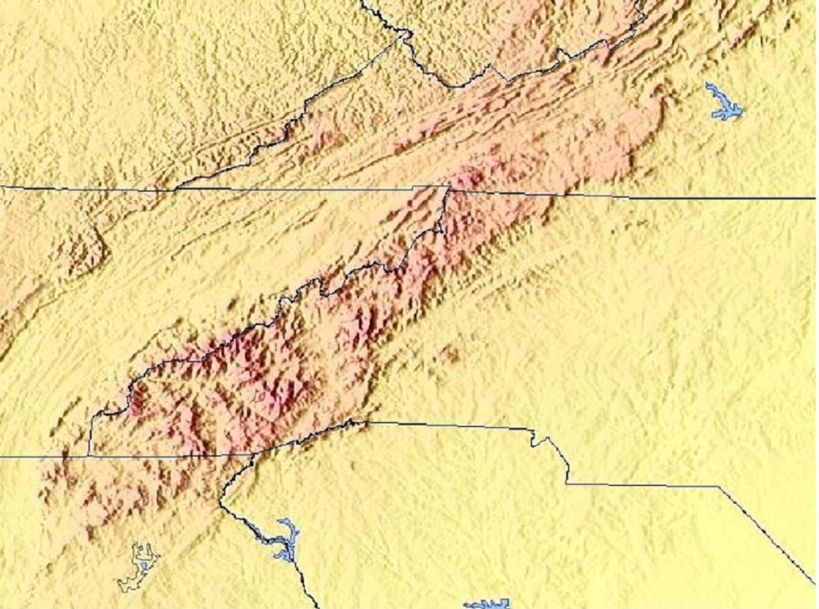
Figure 1. Southern Appalachian mountain range.
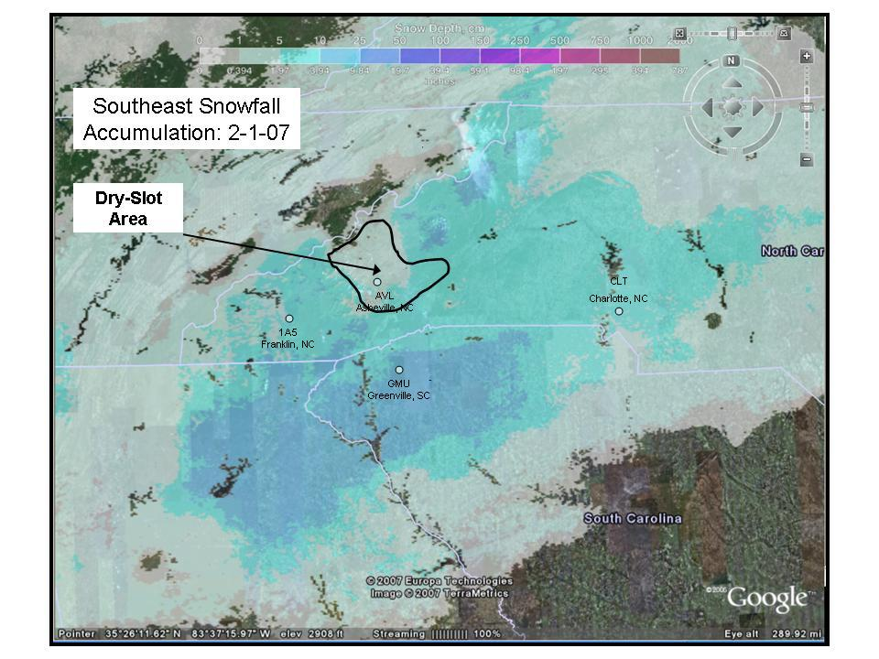
Figure 2. Satellite-based precipitation accumulation estimates valid 1 Feb 2007 (courtesy Greg Dobson, NEMAC).

sleet, and freezing rain in Northeast Georgia, Upstate South Carolina, and the Piedmont of North Carolina (Figure 2). In Asheville and the surrounding communities just east of the Blue Ridge, there was very little accumulation of precipitation (labeled “Dry-Slot Area” in Fig. 2).

It has been noted in Nuss and Miller (2001) based on computer weather model simulations that a slight error in the wind direction forecast can cause a dramatic change in the predicted accumulated precipitation due to an unexpectedly large component of the flow cutting across the mountain ridgeline rather than parallel to it. This has also been observed for a wintertime case during an extensive field experiment along the coastal mountains of California (Ralph et al. 2003). One emphasis of this study will be to examine if the operational forecast models had a systematic wind direction error before and during the event that led to an over-prediction of accumulated precipitation in the Asheville region.

  - Forecast

The National Weather Service Forecast Office – Greenville Spartanburg (NWSFO -GSP) area forecast discussion 12 hours prior to the onset of precipitation as well as the Mesoscale Discussion product issued by the Storm Prediction Center (SPC) both focused on an area of low pressure developing in the western Gulf of Mexico and the associated warm front extending along the Gulf Coast translating northeastward into the southern states through
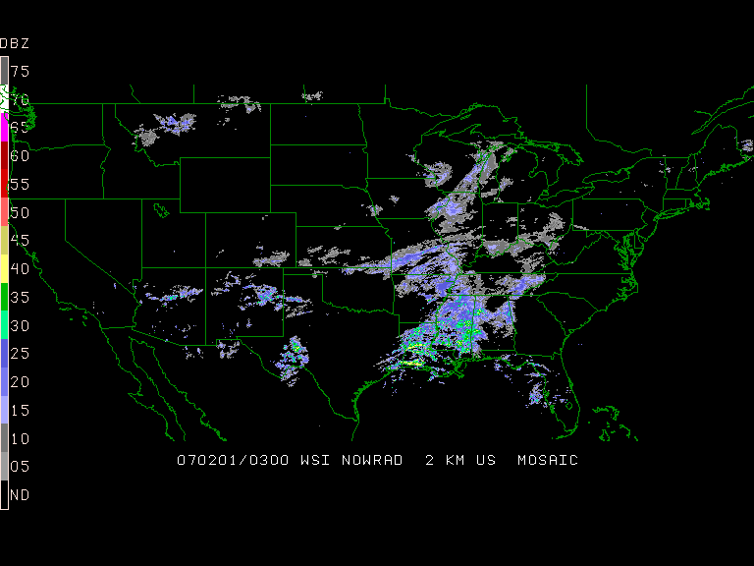
Figure 3. WSI NOWRAD 2 km composite valid 0300 UTC 1 Feb 2007.

the early morning hours of 1 February 2007 (Figure 3). The Hydrometeorological Prediction Center (HPC) surface weather map for this day (Figure 4) depicts the low pressure and predicted areas of precipitation.

Local predictions were based primarily on NAM and GFS model simulations and depicted precipitation reaching the area by 1200 UTC 1 February. A Winter Storm Warning was issued at 2:37 pm EST on 31 January 2007 for the entire County Warning Area (CWA) with accumulations of snow predicted to be in the 2-4 inch range in the Asheville area, with lower amounts south and east as warm air advection was modeled to occur by midday to early afternoon on 1 February 2007.

The early morning radar, satellite, surface observations (Figure 5), and a special Greensboro, NC sounding (not shown) indicated

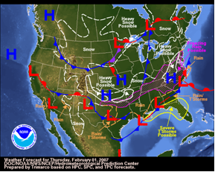
Figure 4. Hydrometeorological Prediction Center (HPC) forecast map valid 1 Feb 2007.
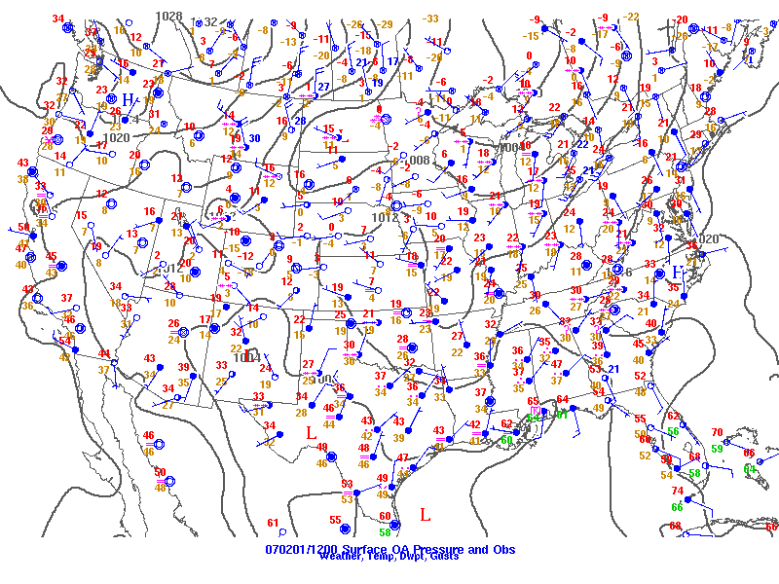
Figure 5. Sea level pressure map and surface observations valid 1200 UTC 1 Feb 2007.

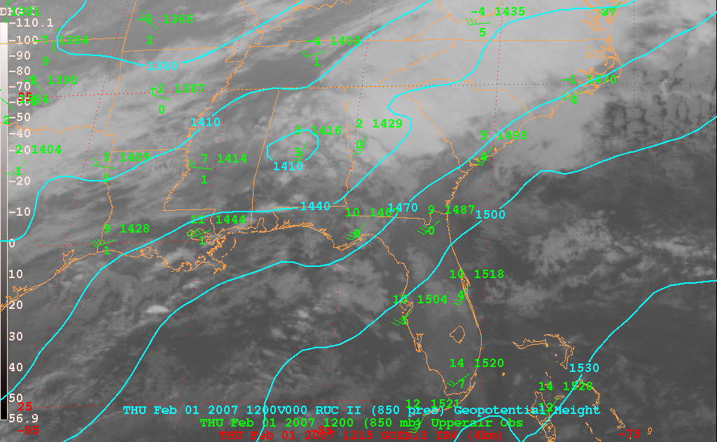
Figure 6. 850 hPa RUC geopotential height analysis (m) valid 1200 UTC 1 Feb 2007 with GOES-12 IR imagery and 850 hPa sounding observations.

frontogenesis occurring with a rapid progression of the associated precipitation. The early morning model runs showed colder air at mid-levels than those from earlier runs and thus a longer period of snowfall was predicted before the P-type changed to a sleet/freezing rain mix.

  - Analysis

The RUC 850 hPa level analysis valid at 1200 UTC 1 February (Figure 6) clearly shows significant cloud cover over the AVL forecast region associated with a closed low pressure system positioned over central Alabama. The corresponding RUC 500 hPa level analysis (Figure 7) shows that the storm is evolving on the downstream side of a broad trough and the AVL forecast area is on the border of the 5400 thickness line typically used in winter weather precipitation forecasts. The corresponding RUC 300 hPa level analysis (Figure 8) shows the
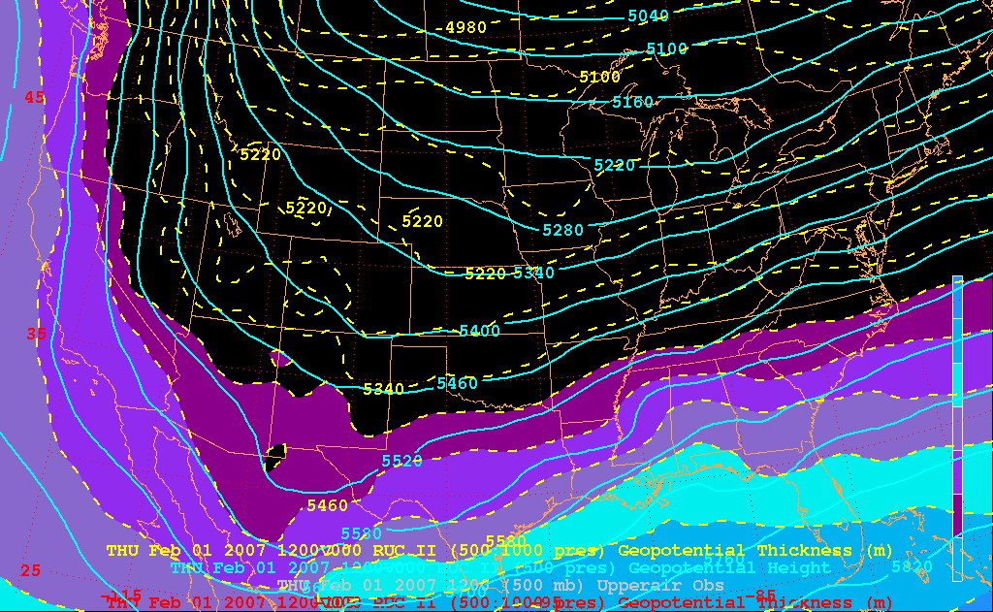
Figure 7. 500 hPa RUC geopotential height (solid contours, m) and 1000-500 hPa thickness analyses (dashed contours, m, shading for thicknesses above 5400 m) valid 1200 UTC 1 Feb 2007.

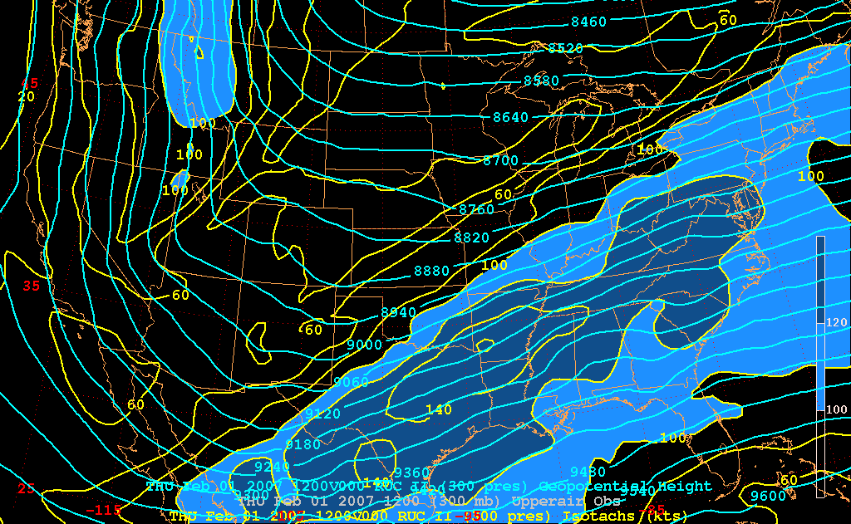
Figure 8. 300 hPa RUC geopotential height (solid contours, m) and isotach analyses (yellow contours, kt, shading for speeds exceeding 100 kt) valid 1200 UTC 1 Feb 2007.

surface storm to be under the right exit quadrant of the upper level jet streak.

P-type observations for AVL and the surrounding area [Greenville, SC (GMU); south of AVL, Charlotte, NC (CLT); southeast of AVL, and Franklin, NC (1A5); southwest of AVL] in Table 1 indicate more sporadic precipitation than had been anticipated at AVL in contrast to the continuous precipitation observed at surrounding stations. Geographic locations of each station are plotted in Figure 2.

Table 1. P-type and intensity observations for stations near Asheville; “S” = snow, “Z” = freezing rain, and “R” = rain. Times in UTC.
Time | 09 | 10 | 11 | 12 | 13 | 14 | 15 | 16 | 17
AVL | S |  | S | S |  |  | Z | Z | S
GMU |  | S | S | S | Z | Z | Z | Z
CLT |  |  | S | S | S+ | S | S | R | Z
1A5 | S | S | S | S | S | S | S | S | S
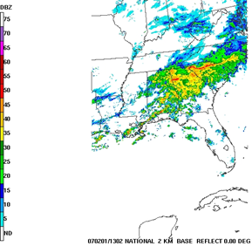
Figure 9. Radar composite of base reflectivity valid at 1300 UTC 1 Feb 2007.

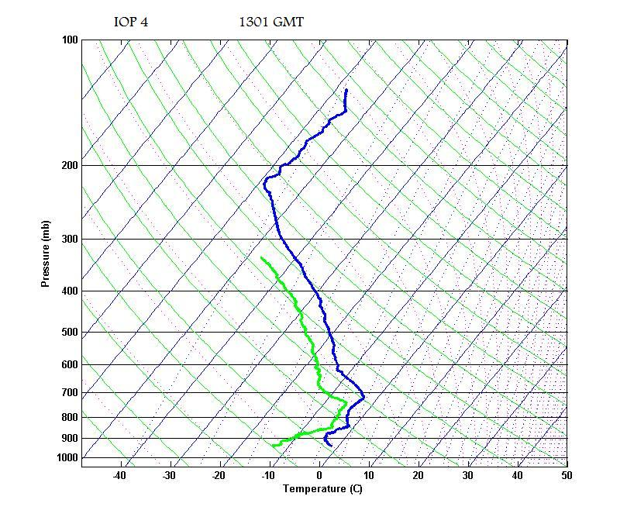
Figure 10. SEMPE vertical profiles of temperature and dewpoint valid at 1301 UTC 1 Feb 2007.

As shown in the base reflectivity image of the southeast from SPC at 1300 UTC 1 Feb 07 (Figure 9), there is a noticeable dry wedge to the east of the WNC Mountains. The purpose of this study is to explain the origin of the dry wedge. A simple hypothesis formulated on the day of the event was that the dry pocket was a result of the winds having a strong cross-mountain component, with its associated downslope warming and drying. However, analysis of the SEMPE 1300 UTC 1 February 2007 sounding vertical thermal (Figure 10) and wind (Figure 11) profiles suggests a different explanation. It is noted that
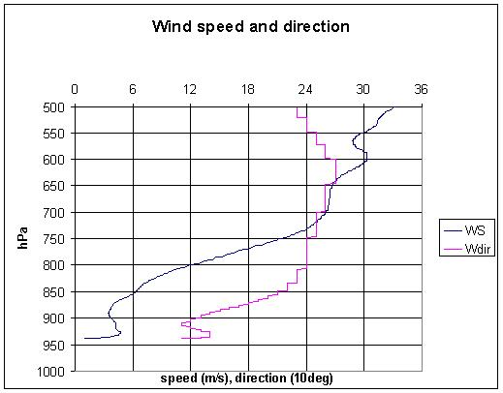
Figure 11. As in Figure 10, except vertical profiles of wind speed (m/s) and direction (tens of degrees).

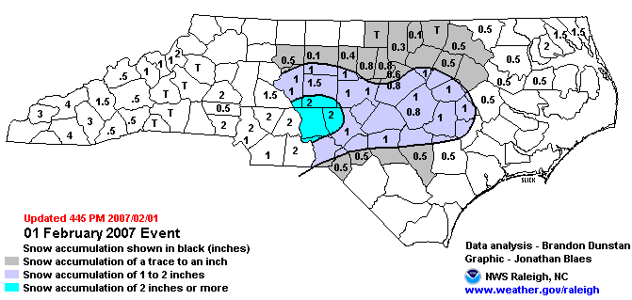
Figure 12. Snowfall Accumulation map of NC for the 1 Feb 2007 winter storm. (Courtesy NWSFO-RAH).

at the height of the nearby mountains (approximately 1525 m or the 840 hPa level), the wind direction is 210 – 240º and the mean mountain ridge axis (see Figure 1) is approximately parallel to 240º. As the day progresses, the mountain-top wind direction shifts to a more southerly direction in response to the movement of the warm front aloft. The cross-mountain wind hypothesis is further disproved by the snowfall accumulations observed in the southwestern portion of Western North Carolina as seen in state-wide accumulation map produced by NWS Raleigh (Figure 12).

- NUMERICAL GUIDANCE

The model of choice of the forecasters during this event was the GFS due to its better handling of the cold air at mid-levels. The actual 850 hPa-level storm track was slightly south of the model prediction (Figure 13). This would partly explain why the observed moisture in the lower
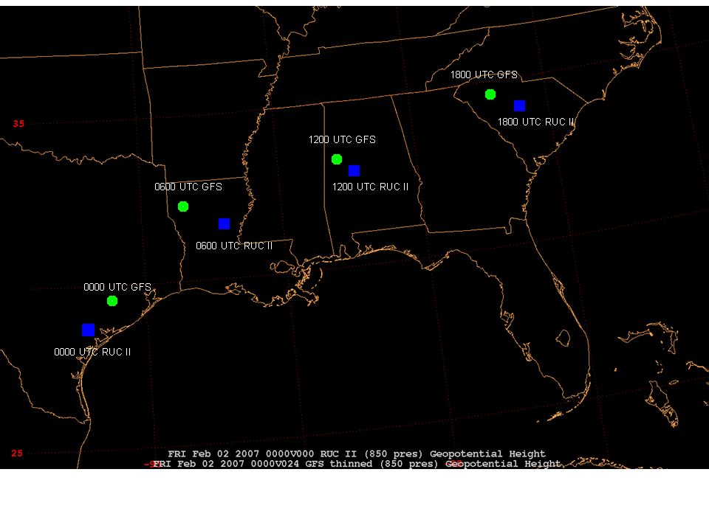
Figure 13. Storm Track of the 850 hPa-level low center with a comparison between the 0000 UTC 1 Feb 2007 GFS Model run (green) and RUC II analyses (blue).

atmosphere was less than predicted. A careful comparison of the GFS model sounding (Figure 14) to the actual SEMPE sounding at 1300 UTC (Figures 10 and 11) shows that the winds above the mountains are in agreement. It is interesting to note that the observed sounding has a significantly stronger temperature inversion near the surface than the models had predicted. This feature could be a contributor to maintaining the pocket of dry air in the “bowl” surrounding Asheville, thus creating one more impediment to the moistening of the low-level air and the accumulation of precipitation.

Warm air advection was forecasted to occur in the CWA by the afternoon (local time) switching the P-type over to a wintry mix. As seen in the SEMPE Skew-T diagrams (Figure 10) there was a slight warm nose that bumped upper-level temperatures to and slightly above freezing, but much less than had been anticipated. The warm nose was short lived as well, as is evident in the hourly P-type observations shown in Table 1. A slight warming changed the light snowfall over to freezing rain for a period of approximately two hours and, just as suddenly as the warm nose had appeared, it eroded when the freezing rain changed back to snow at 1700 UTC 1 February 2007.

- PRELIMINARY CONCLUSIONS

The original hypothesis to account for the dry wedge in Asheville during the 1 February 2007 mixed precipitation event was downslope warming and drying associated with cross-
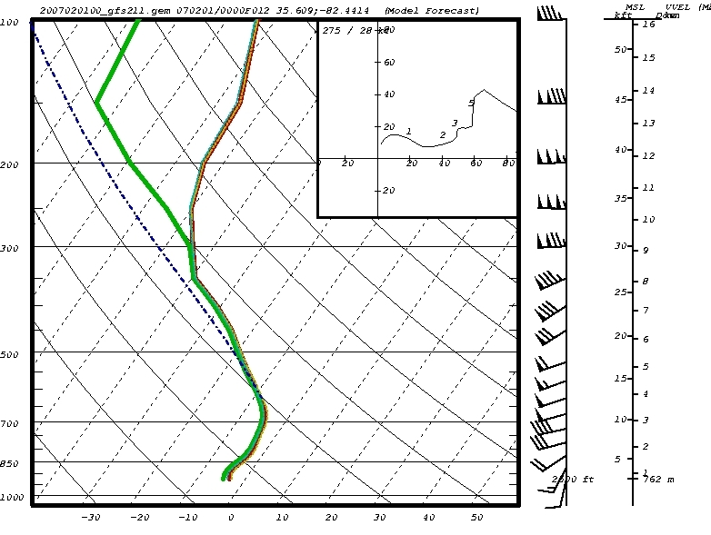
Figure 14. GFS Model Sounding initialized at 0000 UTC 1 Feb 2007 valid at 1200 UTC 1 Feb 2007.

mountain flow. Upon further investigation this hypothesis is at odds with some of the observations (see Section 2.2).

The new working hypothesis invokes a non-classical cold air damming event wherein high pressure at the surface positioned near the NC coast (Figure 5) transported cold air westward as it moved off the coast. The pool of cold dry air when coming in from the east banked against the spine of the Blue Ridge Mountains and settled into a geological bowl that exists in the AVL region. The cold dry air was held in place by a local pressure gradient that resulted in continuous south-southeasterly flow observed at AVL at the surface (not shown). This pool of cold dry air was also held in place due to the absence of vertical mixing which was all but eliminated due to the light low-level winds and the strong inversion overhead. The combination of these influences created a persistent pool of cold air, some of which was accounted for in the 0000 UTC 1 February 2007 GFS model simulation as local forecasters pointed out that the cold dry air would be a challenge to overcome by moistening due to the evaporation of precipitation. It was believed that the abundance of moisture accompanying the storm would be able to do so. The difference in the storm track between what was predicted and what was observed (Figure 13) indicates that the actual moisture amounts accompanying the storm at mid-levels in the AVL region was less abundant than what had been predicted. It is also possible, similar to what was noted in Ralph et al. (2003), that the AVL region was in a moisture shadow aloft, with most of the moisture being consumed to produce the precipitation observed at upstream locations (e.g. Franklin, NC). The decreased moisture aloft compared with expectations based on model predictions led to a decreased rate of precipitation aloft which was unable to sufficiently moisten the cold dry air at low levels, thereby preventing significant amounts of precipitation from reaching the ground at AVL.

- FURTHER ANALYSIS

Further analysis of the 1 February 2007 mixed precipitation weather event is warranted through a detailed examination of the cold air “bowl hypothesis.” The evolution of the event will be explored by investigating available observations, soundings, and RUC analyses and forecasts during the 0900 – 1800 UTC 1 Feb 2007 time period. A careful analysis will determine if the nearby mountains did in fact act as a bowl and “trap” a pocket of cold dry air that was unique to the AVL region. The results of this analysis will be a focus of the conference presentation.

A basic question that will also be investigated is whether the operational model forecasts were errant due to the coarse model resolution, which may not resolve adequately the local mountains and would be unable to account for mesoscale effects (e.g. the “bowl”). It is also quite possible that the model forecast errors were due primarily to the errors made for synoptic-scale weather features (see Figure 13). A determination of the primary source of model error will also be a focus of the conference presentation.

Finally, the study would benefit by exploring historical storm data for the AVL region to determine if examples of locally reduced precipitation have occurred and, if so, note similarities in atmospheric structure that existed between these events and the 1 February 2007 case study. Examination of multiple case studies having local minima in accumulated precipitation for the AVL region would allow for testing and refinement of the “bowl” hypothesis. Results from the historical investigation will also be a focus of the conference presentation.

- ACKNOWLEDGEMENTS

The authors would like to thank the Cooperative Program for Operational Meteorology, Education and Training (COMET) and the National Environmental Modeling and Analysis Center (NEMAC) for their support of the SEMPE project. The authors would also like to thank the Renaissance Computing Institute (RENCI) and the Summer Research Program at UNC Asheville for their support of this research. A final acknowledgement must be extended to Karin Joslin of Warren Wilson College and to Richard Lind of the Naval Postgraduate School for allowing us to borrow equipment and space during the SEMPE field program.

- REFERENCES

Bell, G.D., and L.F. Bosart, 1988: Appalachian cold-air damming. Mon. Wea. Rev., 116, 137-161.

Forbes, G.S., R.A. Anthes, and D.W. Thompson, 1987: Synoptic and mesoscale aspects of an Appalachian ice storm associated with cold-air damming. Mon. Wea. Rev., 115, 564-591.

Keeter, K.K. and co-authors, 1995: Winter weather forecasting throughout the Eastern United States. Part III: The effects of topography and the variability of winter weather in the Carolinas and Virginia. Weather and Forecasting, 10-1, 42-60.

Nuss. W.A., and D.K. Miller, 2001: Mesoscale predictability under various synoptic regimes. Nonlinear Processes in Geophysics, 8, 429-438

Ralph, F.M., and co-authors, 2003: The impact of a prominent rain shadow on flooding in California’s Santa Cruz Mountains: A CALJET case study and sensitivity to the ENSO Cycle. Journal of Hydrometeorology, 4, 1243-1264

Ralph, F.M., and co-authors, 2005: Improving short-term (0-48 h) cool-season quantitative precipitation forecasting. Bull. Amer. Meteor. Soc., 86, 1619-1632.

